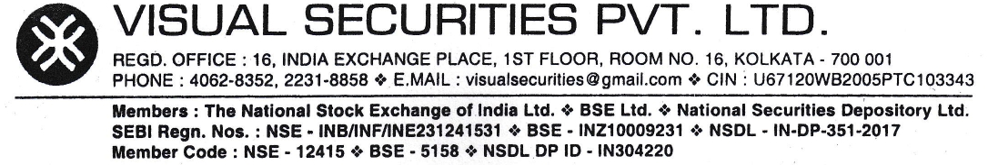

Account Opening Procedure

Below are the steps followed to open an account:
- Decide and pick the accounts you would like to open (Equity, F&O etc). The documents include the account opening forms which includes the KYC forms.
- Print out these forms, and fill in the required fields.
- You will also need 2 passport-size, self-attested photographs to affix in these forms.
- Sign at the required places on the form, and attach your self-attested personal documents (PAN card, ID proof, address proof and other documents as specified in the form).
- Attach a cancelled cheque to link your bank account.
Once completed, send the forms along with your personal documents to the address mentioned here:
Visual Securities Private Limited,
16, India Exchange Road,
1st Floor, Room No. -16, Kolkata 700 001

- In case of any deficiency in the form/supporting documents, the form along with documents are returned to the client after intimation of the discrepancy over the phone/email/letter.
- In case of proper form and supporting documents, the KRA status of the PAN is checked along with details as per KRA database (if PAN is registered) and the details mentioned in the form. If there is any difference between details mentioned in the form and that in KRA database, the KRA database is updated. In case PAN is not registered in KRA, a new record is entered and documents uploaded as per requirement.
- The same process (step 2 above) is done with CKYC database.
- Once KRA as well as CKYC is registered, demat account is opened first (if requested by client), followed by trading account (if requested by client). The accounts once opened and approved by DP/Exchange, is mapped to respective dealer(s) trading terminal.
- Intimation of account opening along with copy of client masters and other statutory documents is sent to the client as part of the welcome kit.

REGD. OFFICE : 16, INDIA EXCHANGE PLACE, 1ST FLOOR, ROOM NO. 16, KOLKATA – 700 001
PHONE : 4062-8352, 2231-8858 ✾ E.MAIL : visualsecurities@gmail.com ✾ CIN : U67120WB2005PTC103343

